**Bug # 1: Car models information not opening on Fire fox**

SUT:

Firefox browser v86.0

Steps:

* Open the browser and enter URL <https://buggy.justtestit.org/>
* Click on Car overall rating. User is redirect to <https://buggy.justtestit.org/overall>.
* Click on any link under car Model. (In my test I clicked on “[Rally 037](https://buggy.justtestit.org/model/c0bm09jgagshpkqbsv00|c0bm09jgagshpkqbsv2g)”)
* Page goes into infinite loading state and data is not retrieved.
* In Browser console GET request is returning status code 400 Bad Request
* Note: The same bug can be observed on opening same page on fir fox browser on Mobile and Tablet.

Console Logs:

GET: https://k51qryqov3.execute-api.ap-southeast-2.amazonaws.com/prod/models/c0bm09jgagshpkqbsv00|c0bm09jgagshpkqbsv2g

Status: 400Bad Request

Version: HTTP/2

Cross-Origin Request Blocked: The Same Origin Policy disallows reading the remote resource at <https://k51qryqov3.execute-api.ap-southeast-2.amazonaws.com/prod/models/c0bm09jgagshpkqbsv00>|c0bm09jgagshpkqbsv2g. (Reason: CORS header ‘Access-Control-Allow-Origin’ missing).

EXCEPTION: Unknown error [browser_adapter.js:84](webpack://~/@angular/platform-browser/src/browser/browser_adapter.js)

    Angular 5

    RxJS 7

    Angular 10

    addEventListener polyfills.a422f97fa3b20eceb79d.js line 46 > Function:3

    response Angular

    RxJS 7

    refresh model.component.ts:64

    ngOnInit model.component.ts:36

    RxJS 6

    ngOnInit model.component.ts:34

    detectChangesInternal t.template.js:28

    Angular 2

    detectChangesInternal e.template.js:222

    Angular 16

    RxJS 7

    Angular 14

    setTimeout polyfills.a422f97fa3b20eceb79d.js line 46 > Function:3

    Angular 35

    0 main.ts:17

Screenshot:

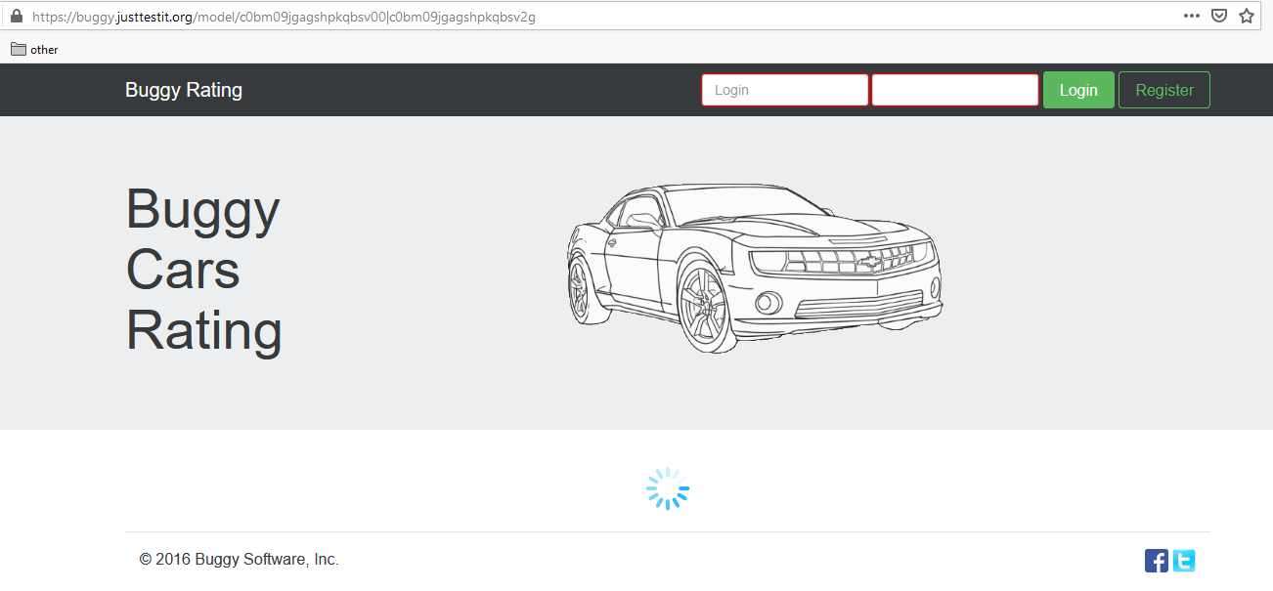

**Bug # 2: Missing information and missing image on cars**

SUT:

Chrome browser v88.0.4324.190

 Steps:

* Open the browser and enter URL <https://buggy.justtestit.org/>
* Click on Car overall rating. User is redirect to <https://buggy.justtestit.org/overall>.
* Search for car with Make “[Lancia](https://buggy.justtestit.org/make/c0bm09jgagshpkqbsv00)” and click on it.
* Click on the model “[Stratos](https://buggy.justtestit.org/model/c0bm09jgagshpkqbsv00%7Cc0bm09jgagshpkqbsv3g)”. The page has missing information. (URL <https://buggy.justtestit.org/model/c0bm09jgagshpkqbsv00%7Cc0bm09jgagshpkqbsv3g>)
* Repeat the above steps for finding Make “[Lancia](https://buggy.justtestit.org/make/c0bm09jgagshpkqbsv00)” again
* Click on model “[Ypsilon](https://buggy.justtestit.org/model/c0bm09jgagshpkqbsv00%7Cc0bm09jgagshpkqbsv1g)”. This page has missing image. (URL <https://buggy.justtestit.org/model/c0bm09jgagshpkqbsv00%7Cc0bm09jgagshpkqbsv1g>)

Screenshot

Model [Stratos](https://buggy.justtestit.org/model/c0bm09jgagshpkqbsv00%7Cc0bm09jgagshpkqbsv3g)

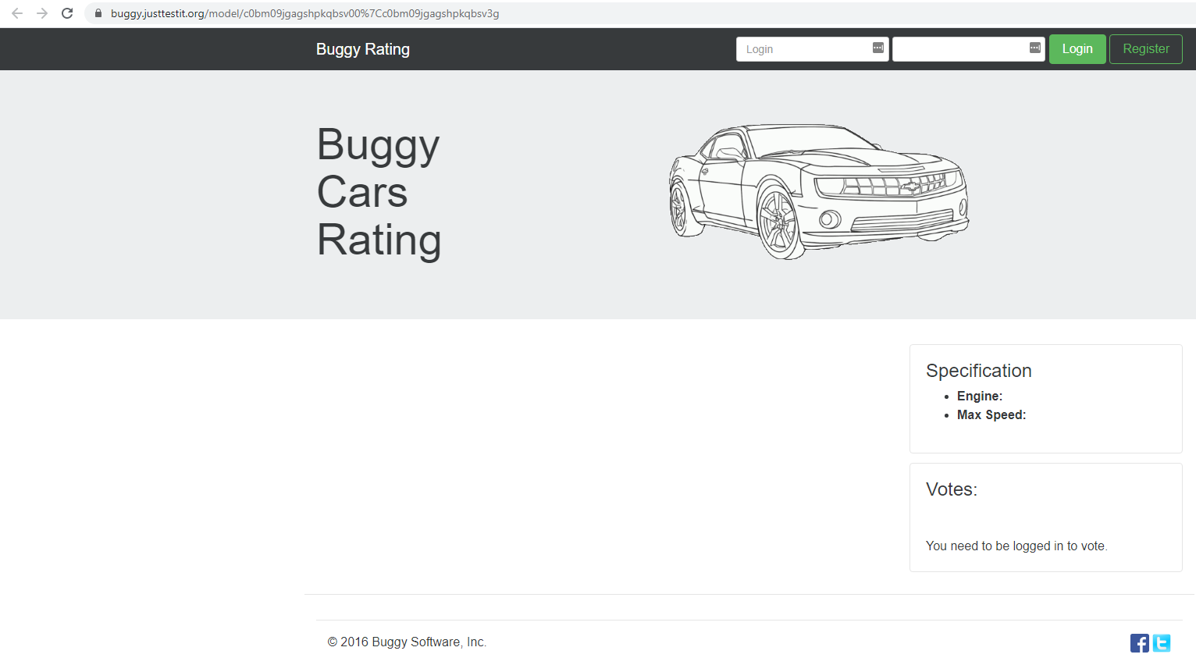

Model [Ypsilon](https://buggy.justtestit.org/model/c0bm09jgagshpkqbsv00%7Cc0bm09jgagshpkqbsv1g)

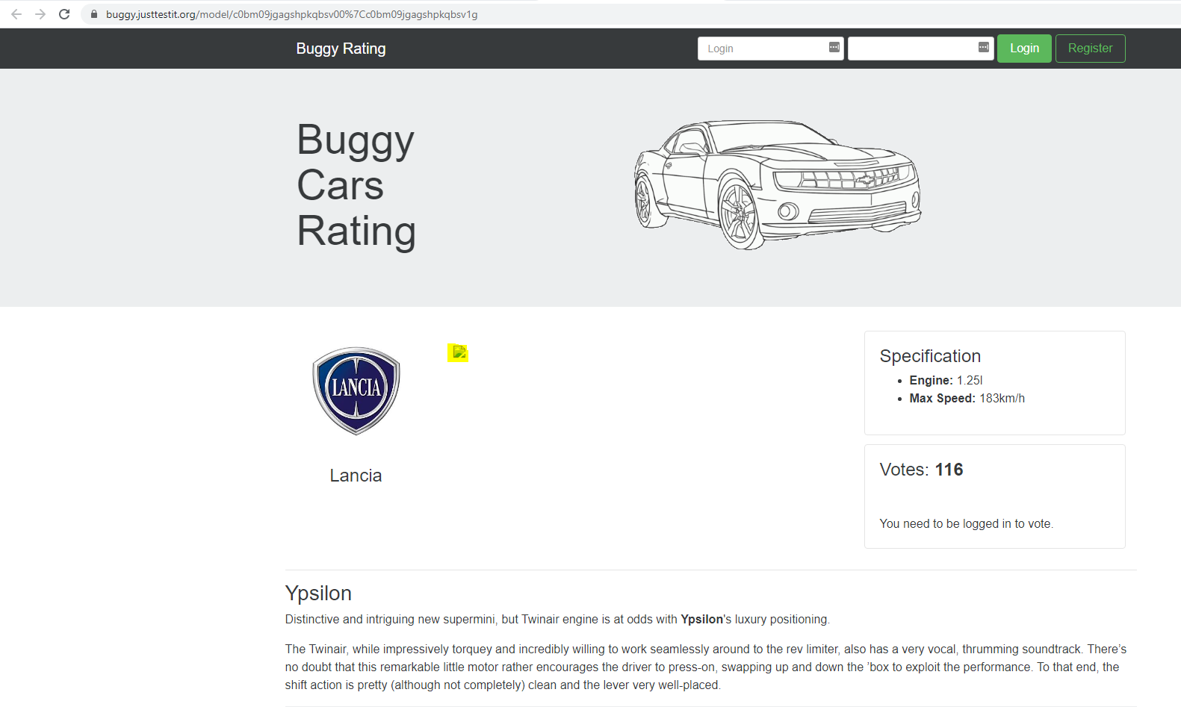

**Bug # 3: Broken link to home screen of all Car Make pages**

SUT:

Chrome browser v88.0.4324.190

 Steps:

* Open the browser and enter URL <https://buggy.justtestit.org/>
* Click on Car overall rating. User will be redirect to <https://buggy.justtestit.org/overall>.
* Click on any link under Car Make. (In my test I clicked on “[Pagani](https://buggy.justtestit.org/make/c0bm09jgagshpkqbsuq0)”
* Home button on left top does not work.
* If I hover over it, I can see <https://buggy.justtestit.org/broken>
* On clicking on it I see following in console logs

Console Logs:

browser_adapter.js:93 EXCEPTION: Error: Uncaught (in promise): Error: Cannot match any routes: 'broken'

browser_adapter.js:84 Error: Uncaught (in promise): Error: Cannot match any routes: 'broken'

at l (zone.js:538)

at zone.js:515

at e.invoke (zone.js:323)

at Object.onInvoke (ng_zone_impl.js:53)

at e.invoke (zone.js:322)

at e.run (zone.js:216)

at zone.js:571

at e.invokeTask (zone.js:356)

at Object.onInvokeTask (ng_zone_impl.js:44)

at e.invokeTask (zone.js:355)

zone.js:461 Unhandled Promise rejection: Cannot match any routes: 'broken' ; Zone: angular ; Task: Promise.then ; Value: Error: Cannot match any routes: 'broken'

at t._subscribe (apply_redirects.js:37)

at t.subscribe (Observable.js:52)

at t._subscribe (Observable.js:109)

at t.call (mergeMap.js:75)

at t.subscribe (Observable.js:52)

at t._subscribe (Observable.js:109)

at t.call (mergeMap.js:75)

at t.subscribe (Observable.js:52)

at t._subscribe (Observable.js:109)

at t.call (map.js:54)

Screenshot:

